**SOLUTION DESIGN DOCUMENT**

Version 2.3

**FA Rework Invoices**

Revision History

Version History

|  |  |  |  |
| --- | --- | --- | --- |
| Date | Revision | Author | Description |
| 25-01-2024 | 1.0 | Almas Gajendragad / Ravi Teja Ragam | Reviewed |
| 29-02-2024 | 2.0 | Almas Gajendragad | Draft Version |
| 06-03-2024 | 2.1 | Almas Gajendragad | Draft Version |
| 08-04-2024 | 2.2 | Clifton Lenne / Subhasri Samaddar | Draft Version |
| 30-04-2024 | 2.3 | Clifton Lenne / Subhasri Samaddar | Final Version |

Validation

|  |  |  |  |
| --- | --- | --- | --- |
| Date | Revision | Name | Approval |
| 25-01-2024 | 1.0 |  | Review |
|  |  |  |  |
|  |  |  |  |

Contents

Revision History 1

Version History 1

Validation 1

Distribution 3

Introduction 4

Overview 4

Solution Architecture 4

Solution Overview 4

Solution Design Workflow 6

Solution Components 6

Power Platform Data Connectors 7

Microsoft Dataverse 7

Microsoft Power Apps 11

Microsoft Power Automate 14

Power Platform Dataflow 16

Environmental Setup 19

License Requirements 19

Service account 19

Business Users 19

# Distribution

The information has restricted distribution and viewing within Chanel.

Document Sign-off Requirements

The following table contains the people required to sign-off and/or review this document and those that require the document for information only.

|  |  |  |
| --- | --- | --- |
| Name | Department | Responsibility |
|  |  |  |
|  |  |  |

# Introduction

## Overview

The Objective of this solution is to convert a PoC to a production ready application that allows APAC business users to view inbound vendor invoice details outside the AX system, overcoming the inefficiencies of the latter. The solution shall:

* Extract ORLI vendor invoice data and save it in Dataverse tables.
* Integrate with AX, fetch data and save it in Dataverse tables.
* Retrieve and display invoice details on the app’s UI screen.
* Send email to Finance team with invoice attachment in PDF or Excel format.

# Solution Architecture

## Solution Overview

The **FA Rework Invoices** app comprises a solution featuring a Canvas app. This app will enable APAC users to efficiently track the status of inbound vendor invoices. By combining the file information generated by the ORLI system with the information stored in Dynamics AX and making it visible and manageable through the App, the slow performance when tracking invoices directly in Dynamics AX is bypassed.

To ensure an optimal performance of the app, thus minimizing the size of the data to be processed, only the relevant data fields are utilized.

The following steps will be performed in the process.

***Retrieve and Store ORLI Data***

* + A scheduled Power Automate Flow checks the ORLI File Server for CSV files, copies these to OneDrive for Business and stores the transformed data in Dataverse.

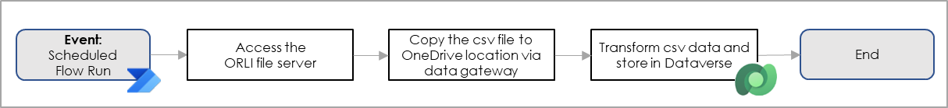

***Retrieve and store AX Data***

* + A scheduled Power Automate Flow runs a Stored SQL Procedure on the AX SQL Database, retrieving the relevant data. Sequentially this data is stored in Dataverse.

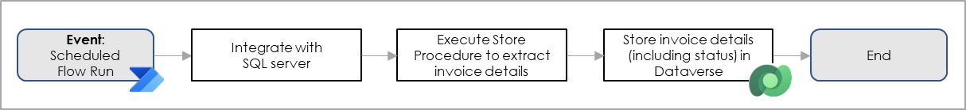

***Search for Single / Multiple Invoices***

* + End user should be allowed to search for invoices. This search entails either a single invoice number, or multiple invoice numbers separated by comma or space.

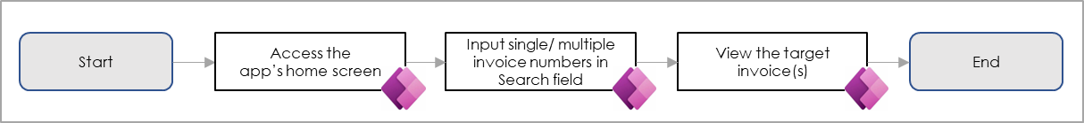

***Filter for List of Invoices***

* + End user should be allowed to filter invoices by date range (with a Start Date that is equal to the End Date minus 3 months), and division (including FSN).

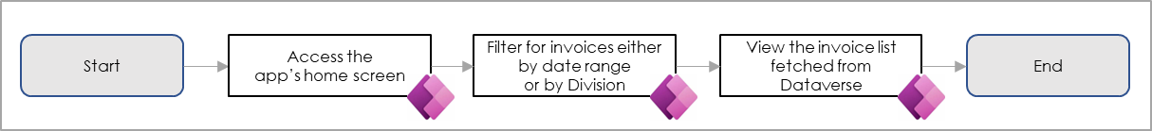

***Navigate to Invoice Details***

* + End user should be allowed to view Invoice Details.

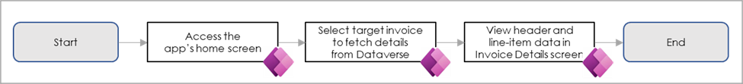

***Email Invoice to Finance Team***

* + End user should be allowed to generate PDF and Excel files and send these as an Attachment to the Finance Team.

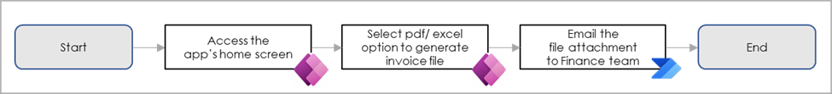

## Solution Design Workflow

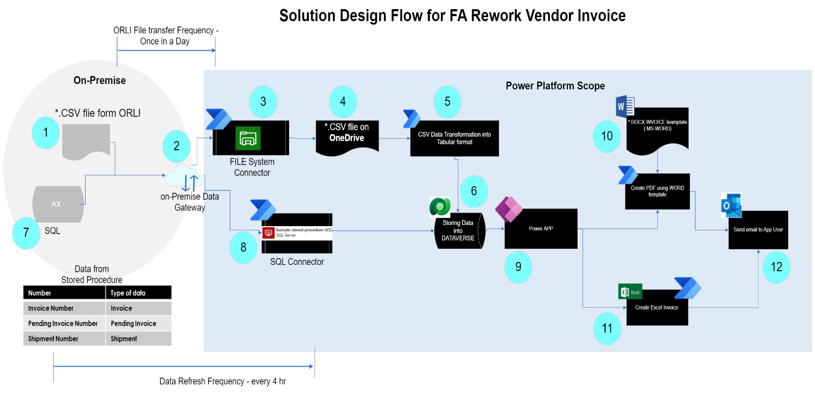

## Solution Components

This Power Platform Solution makes us of the following Ecosystem**[1]** components:

|  |  |  |
| --- | --- | --- |
| **Component** | **Description** | **Value** |
| File Share | Location of generated CSV ORLI File | \\HKDATAPAXU02\AX_Interface\UAT\CHK\NumdeNumin\Archive |
| OneDrive for Business | Target location of CSV file once copied from ORLI File Share | * Copy of CSV ORLI File |
| Microsoft Dataverse | Storage of transformed and merged data | * Table 1: Header_Invoice_FA Rework * Table 2: Items_Invoice_FA Rework * Table 3: VendInvoiceShipmentStatus * Table 4: Invoice-status-history * Table 5: Inventory_Variant_FA_Rework |
| Power Platform On-Premises Data Gateway | Integrates Power Platform Services with the On-Premises File Share | * SA-APACFARework_DGW |
| Power Apps | Main Application |  |
| Power Automate | Low Code orchestration of ETL processes, and management of notifications |  |
| Power Platform Data Connectors | Connectors used by the Main application and the corresponding (data)flows. | * Connector 1: Excel Online (Business) * Connector 2: File System * Connector 3: Microsoft Dataverse * Connector 4: Office 365 Outlook * Connector 5: Microsoft OneDrive for Business * Connector 6: Microsoft SharePoint * Connector 7: Microsoft SQL * Connector 8: Word Online (Business) * Connector 9: HTTP with Microsoft Entra ID (preauthorized)   Connection References: |
| Power Platform Dataflows | * Ingest Inventory Variant data in Inventory Variant Table utilizing Power Query * Ingest Vendor Invoice and Shipment Status data in Vendor Invoice and Shipment Status Table | * Df_Inventory_Variant_FA_Rework * DF_VendInvoiceShipmentStatus_FA_Rework |

### Power Platform Data Connectors

The Power Platform Data Connectors will be used throughout the Power Platform Solution. In the next sections the use of these connectors is highlighted where applicable.

### Microsoft Dataverse

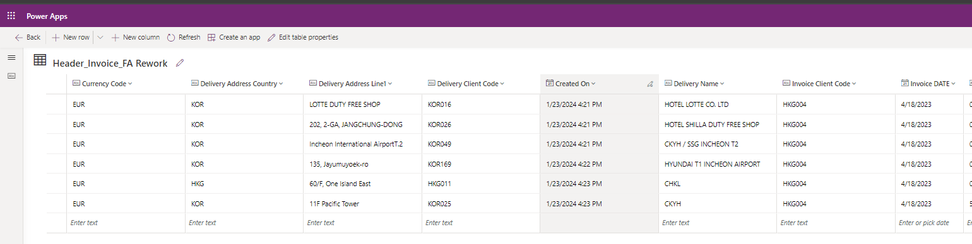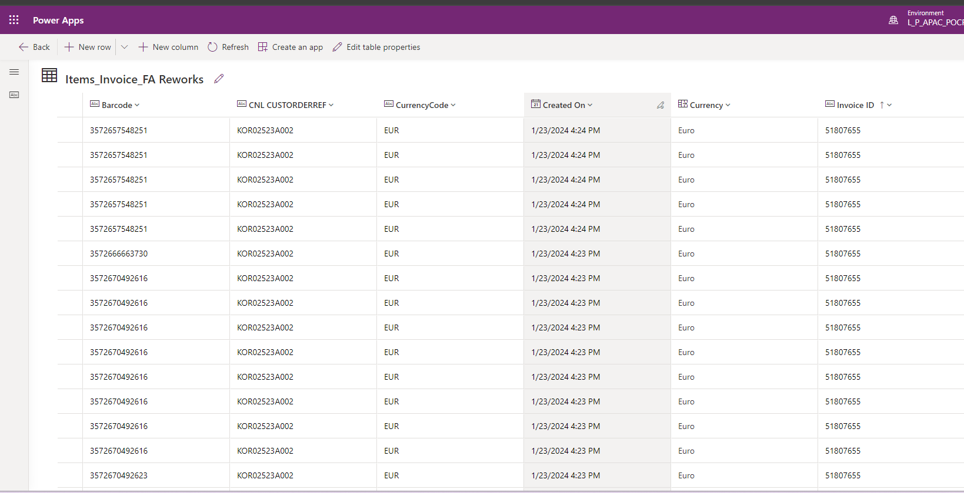The data from CSV file will be transformed and stored into Dataverse tables.

#### Data Tables and Mapping

Overview: This section contains the various mappings and views related to all the tables that are part of the FA Rework Invoices App.

**Entity Relationship Diagram in Dataverse**

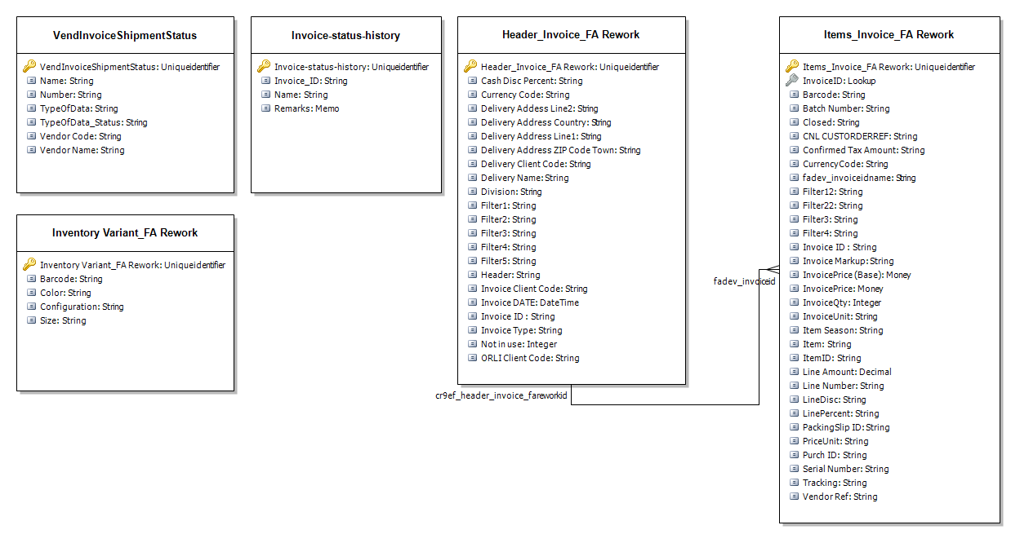

**New Table to store Inventory Variant data.**

An extra ‘standalone’ table needs to be created using the following configuration:

|  |  |
| --- | --- |
| Table Display Name | Inventory_Variant_FA_Rework |
| **Internal Name** | Inventory_Variant_FA_Rework |
| **Description** | Inventory variant details (or other applicable description) |
| **Column 1** | Barcode: String – This should be unique (**Alternate Key:** Key_Barcode) |
| **Column 2** | Size: String |
| **Column 3** | Color: String |
| **Column 4** | Configuration: String |
| **Column 5** | Item Number: String => **Not created, as value already present in ‘Items_Invoice_FA_Rework’ table as ‘Invoice ID’** |

This table will not contain any table relationships with other tables in this Solution. Data will be ingested using a **Power Platform Dataflow**. Values will be retrieved by executing the **CNLAS_GetInventVariants** Stored Procedure.

**Modification of Existing Table to store Vendor Code and Vendor Name.**

2 extra fields need to be created for the **Header_Invoice_FA_Rework** table. These values will be retrieved through the expansion of the existing Stored Procedure **CNLAS_GetVendInvShipmentStatus**:

|  |  |
| --- | --- |
| Table Display Name | Header_Invoice_FA_Rework |
| **Internal Name** | Header_Invoice_FA_Rework |
| **Column 1** | Vendor Code: String |
| **Column 2** | Vendor Name: String |

**Invoice Status and Shipment Status in Dataverse**

**VendInvoiceShipmentStatus** Table represents data for Invoice status and pending Invoice statuses coming from AX SQL after executing stored procedure **CNLAS_GetVendInvShipmentStatus**:

|  |  |  |  |
| --- | --- | --- | --- |
| **Number** | **TypeOfData** | **Created On** | **Status** |
| Invoice Numbers | Shipment | MM/DD/YYYY | Processed/Not Processed |
| Invoice Numbers | Invoice | MM/DD/YYYY | Processed/Not Processed |
| Invoice Numbers | Pending Invoice | MM/DD/YYYY | Processed/Not Processed |

* Number column represents – Invoice ID
* TypeOfData column represents – Status of the respective invoice as Shipment or Pending Invoice or Invoice.
* Date column represents – Date on which the record gets created in Dataverse.
* Status column represents – Status of TypeOfData as Processed or Not

**Data Mapping in AX**

|  |  |  |
| --- | --- | --- |
| **Mapper Type** | **Mapper Name** | **Mapped Id** |
| Header | HEADER | * Invoice Id * Invoice Type * Invoice Date * ORLI Client Code * Invoice Client Code * Delivery Client Code * Delivery Name * Delivery Address Line1 * Delivery Address Line2 * Delivery Address ZIP Code Town * Delivery Address Country * Currency Code * Cash Disc Percent * Filter1 * Filter2 * Filter3 * Filter4 * Filter5 |
| Line | ITEM | * PackingSlip ID * Vendor Ref * CNL CUSTORDERREF * Purch ID * Line Number * Item ID * Barcode * Item Season * Invoice Qty * Invoice Unit * Invoice Price * Price Unit * Currency Code * Closed * Line Disc * Line Percent * Invoice Markup * Confirmed Tax Amount * Line Amount * Filter1 * Filter2 |
| Line | TRACKING | * Serial Number * Batch Number * Filter3 * Filter4 |

### Microsoft Power Apps

#### Canvas App

**Purpose of Canvas application**

The Canvas application is required to display the Invoice Data based on user Search and Filter criteria. The Power App has will have a similar interface as AX.

##### Home Screen

When the user accesses the application, he should see the Home Screen. In the Home Screen he has the following options:

1. Validate the Invoice data.
2. Searching for Invoices via the search bar.
   1. Single or Multi search by entering one or more Invoice Numbers, and consequently selecting those via the dropdown box:

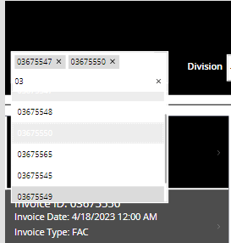

* 1. Multi search by uploading an Excel File with Invoice Numbers:

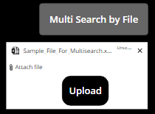

1. Filter the data based on Data Range and Divisions.
   1. Date Range: The Start Data and End Date should be within a range of 3 months.
   2. Division: can be selected via the Dropdown control. By default, no Division is selected, depicted by the ‘**- -**’ value. In that case all Invoices are returned spanning the selected Date Range.



1. Sorting. Invoices can be sorted by Invoice Date, in **ascending** and **descending** order.
2. View invoice details by clicking on the ‘**See Items**’ button.

**Note:** The Search and Filter logic has been modified to also include division. Until recently this was limited to FSN only.

##### Details Screen

This screen displays the details of the selected Invoice. In this screen the user should be allowed to generate and Excel or PDF report to send per attachment to the Finance Team.

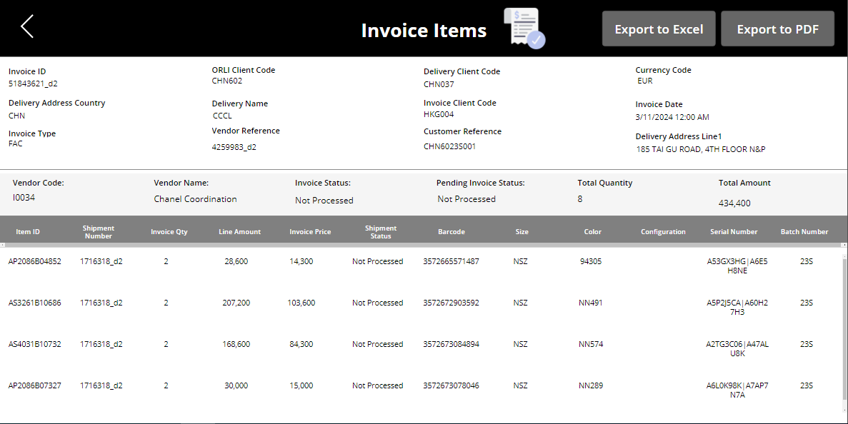

The following changes to be applied to the Invoice Detail screen:

* Include new fields for Header data on the Invoice Details screen:
  + Customer Reference (ref: ORLI Header Data)
  + Vendor Reference (ref: ORLI Header Data)
  + Total Qty (ref: ORLI Line-item Data – sum of Qty)
  + Total Amount (ref: ORLI Line-item Data – sum of amount) with currency
* Include new columns for Line-item data on the Invoice Details screen:
  + Serial number (source: Dataverse)
  + Inventory variants: *(dependent on Stored Procedure* ***CNLAS_GetInventVariants****)*
    - Logic: Lookup(*InvVariantTbl, BardcodeCol = This.BarcodeCol)* 
      * Barcode
      * Size
      * Color
      * Config

**PDF Generation from Details Screen**

The PDF will get generated and will be sent to logged in user via Outlook. To generate this PDF a Microsoft Word template has been used. Therefore, the following template is provided: [**Templates Folder**](https://lpl.sharepoint.com/:f:/r/sites/APACHyperautomation/Shared%20Documents/FA%20Rework%20Inbound%20Vendor%20Invoice/Invoice%20Templates?csf=1&web=1&e=3xaVbR)

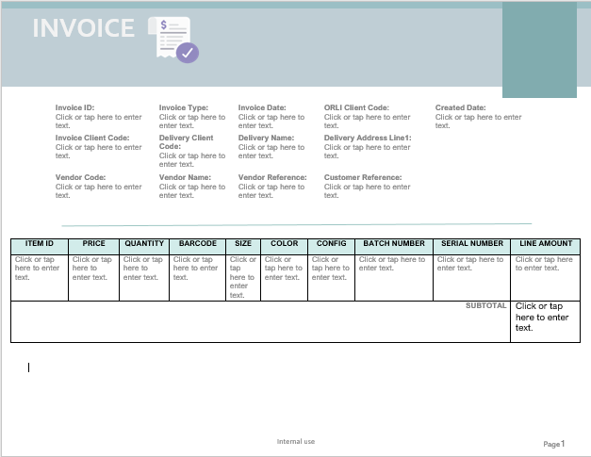

**Excel Generation from Details Screen**

The Excel will get generated and will be sent to logged in user via Outlook. Therefore, the following template is provided: [**Templates Folder**](https://lpl.sharepoint.com/:f:/r/sites/APACHyperautomation/Shared%20Documents/FA%20Rework%20Inbound%20Vendor%20Invoice/Invoice%20Templates?csf=1&web=1&e=3xaVbR)

Note that the Excel Table listing the Invoice Line Items is created and formatted during Flow execution, and therefore does not exist within the provided template.

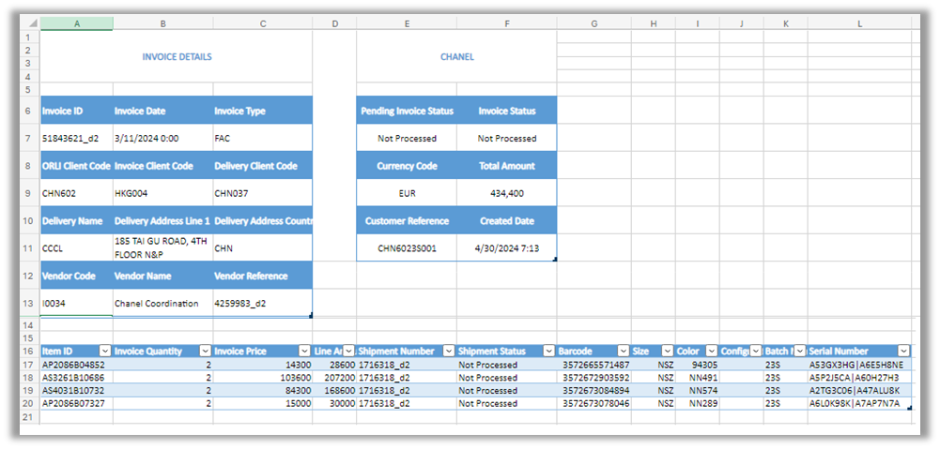

### Microsoft Power Automate

|  |  |
| --- | --- |
| **Name** | **Copy Source File to SharePoint** |
| **Description** | Copies CSV file from ORLI File Path to SharePoint |
| **Trigger** | Automated – File System |
| **Frequency** | Not Applicable |
| **Trigger Condition** | When a file is created (properties only) – File System |
| **Schema** | [**LINK**](https://lpl.sharepoint.com/:f:/s/APACHyperautomation/EsgXZTWULs5IhsiZlZkpcHQBpaOX3hCl97EOdXXUYABZxA) |
| **Connectors** | File System, Microsoft SharePoint |

|  |  |
| --- | --- |
| **Name** | **Transform and Import Data from Source File** |
| **Description** | Transforms CSV data to Master and Line items |
| **Trigger** | Automated – Microsoft SharePoint |
| **Frequency** | N/A |
| **Trigger Condition** | When a file is created – Microsoft SharePoint |
| **Schema** | [**LINK**](https://lpl.sharepoint.com/:f:/s/APACHyperautomation/EsgXZTWULs5IhsiZlZkpcHQBpaOX3hCl97EOdXXUYABZxA) |
| **Connectors** | Microsoft SharePoint, Microsoft Dataverse |
| **Remark** | Flow to be adapted to also extract invoice’s division from ORLI file name and store in Dataverse table. The following file name convention should be used: **NLY_CHK_<Division>_INVOICE_<Market>_<Invoice ID>** |

|  |  |
| --- | --- |
| **Name** | **Upload Multisearch File** |
| **Description** | Uploads invoices directly from within **FA Rework Invoices** app |
| **Trigger** | Instant – PowerApps (V2) |
| **Frequency** | N/A |
| **Trigger Condition** | N/A |
| **Schema** | [**LINK**](https://lpl.sharepoint.com/:f:/s/APACHyperautomation/EsgXZTWULs5IhsiZlZkpcHQBpaOX3hCl97EOdXXUYABZxA) |
| **Connectors** | Microsoft SharePoint, Excel Online (Business) |

|  |  |
| --- | --- |
| **Name** | **Export Invoice to File (Parent + Child)** |
| **Description** | Generates Excel and PDF reports from selected Invoice and sends as Outlook attachment |
| **Trigger** | Instant – PowerApps (V2) + Mobile |
| **Frequency** | N/A |
| **Trigger Condition** | N/A |
| **Schema** | [**LINK**](https://lpl.sharepoint.com/:f:/s/APACHyperautomation/EsgXZTWULs5IhsiZlZkpcHQBpaOX3hCl97EOdXXUYABZxA) |
| **Connectors** | Microsoft Dataverse, OneDrive for Business, Excel Online (Business) , Office 365 Outlook, Microsoft SharePoint |
| **Excel Script** | The following **Excel Script** is executed as part of the Flow: [**LINK**](https://lpl.sharepoint.com/:f:/r/sites/APACHyperautomation/Shared%20Documents/FA%20Rework%20Inbound%20Vendor%20Invoice/Excel%20Scripts?csf=1&web=1&e=tcPfq6)  Location: ODfB (SA-APAFARework)/Office Scripts/FA Rework/DEV-TST-PRD |
| **Changes** | Include two new fields (dependent on newly created Stored Procedure)   * Vendor name * Vendor code |

|  |  |
| --- | --- |
| **Name** | **Add Invoice History Record** |
| **Description** | Created history record in invoice-status-histories table |
| **Trigger** | Automated – Microsoft Dataverse |
| **Trigger Condition** | When a row is added or modified and the ‘TypeOfData_Status’ equals ‘Pending Invoice’ |
| **Frequency** | N/A |
| **Trigger Condition** | N/A |
| **Schema** | [**LINK**](https://lpl.sharepoint.com/:f:/s/APACHyperautomation/EsgXZTWULs5IhsiZlZkpcHQBpaOX3hCl97EOdXXUYABZxA) |
| **Connectors** | Microsoft Dataverse |

### Power Platform Dataflow

For the ingestion of **Inventory Variant** and **Vendor Invoice Shipment Status**, 2 separate Power Platform Dataflows will be used. This capability is utilized for several reasons:

* Duplicate detection
* Upsert feature:
  + If a record does not exist, it will be created.
  + If a record already exists, it will be updated. That is, if the output of the Stored Procedure contains updated data.
* By utilizing Power Platform dataflows, the upsert logic does not have to be configured manually via Power Automate, avoiding the creation of complex Power Automate flows.
* Power Automate is not an adequate ETL Tool for these kinds of scenario’s: the ingestion and validation of thousands of records at the time.

**Setup Power Platform Dataflow**

* **Power Platform Dataflow Name:**
  + Inventory Variant:Df_Inventory_Variant_FA_Rework
  + Shipment Status: DF_VendInvoiceShipmentStatus_FA_Rework
* **Analytical Enities Only:** FALSE

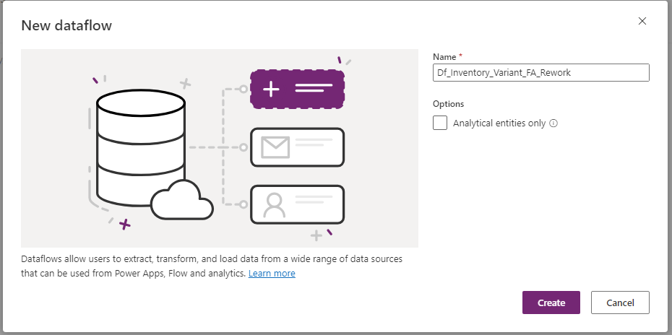

Figure 1 New Dataflow: Df_Inventory_Variant_FA_Rework

* **Data Source:** SQL Server Database
* **Server:** *Name_of_SQL_Server*
* **Database**: *Name_of_Database*
* **SQL Statement**:
  + Inventory Variant: EXECUTE [dbo].[CNLAS_GetInventVariants]
  + Shipment Status: EXECUTE [dbo].[CNLAS_GetVentInvShipmentStatus]

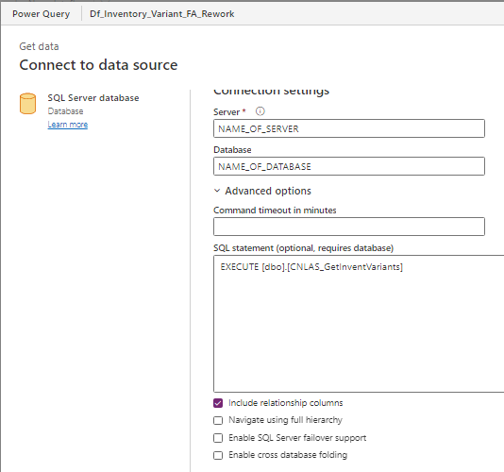

Figure 2 Connection Settings

* **Connection:** Use Existing SQL Connection or Create New One
  + Utilizes following Power Platform Data Connector: **HTTP with Microsoft Entra ID (preauthorized)**
* **Connection Name:** *Updated Automatically*
* **Data Gateway**: *Name_of_Data_Gateway*
* **Authentication kind**: **Organizational Account**
* **Use Encrypted Connection**: TRUE

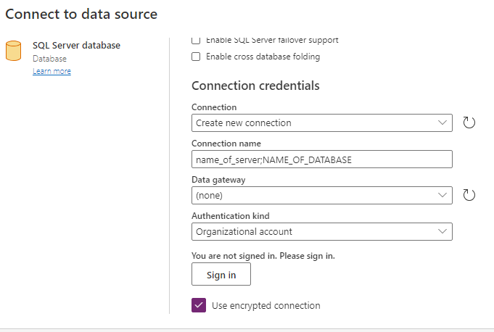

Figure 3 Connection Credentials

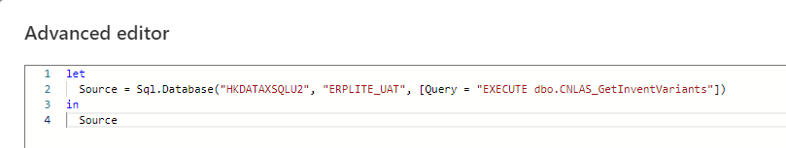

Figure 4 M-Query: Inventory Variants

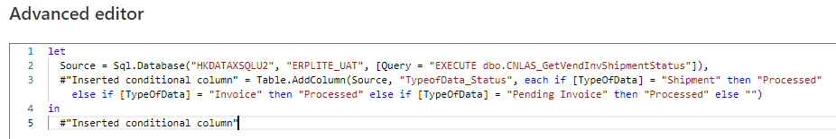

Figure 5 M-Query: Vendor and Shipment Status

Before continuing to the next step, ensure that Inventory Variant Table exists, and the Alternate keys are defined:

* Inventory Variant Table:
  + Column(s): **Barcode**
  + Key Name: **Key_Barcode**
* VendInvShipmentStatus:
  + Column(s): **Number**, **Type Of Data**
  + Key Name: **Key_Number_TypeOfData**

Data will be ingested in this table using these alternate keys as reference. Based on these keys the Dataflow will know which rows need to be created and updated (and optionally removed).

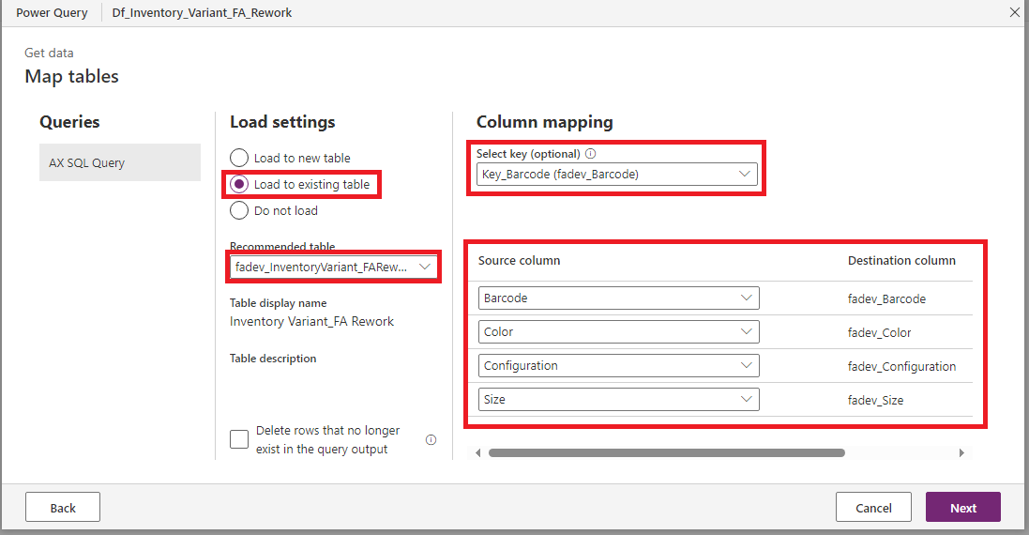

Figure 7 DATA INGESTION INTO DATAVERSE

* **Refresh Settings:**
  + **Refresh Method**: Automatically
  + **Frequency Based**: Refresh every 4 hours.
  + **Send Refresh failure notification to dataflow owner**: TRUE.

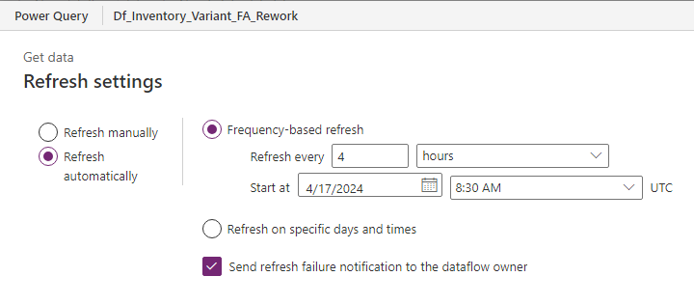

Figure 8 REFRESH SETTINGS

Frequency set to occur **every 4 hours** in current setup for both Dataflows.

**Note**: When you invoke the SQL query you may get a prompt asking for permission to run a native database query. This is a caution to warn you that some SQL query is being run which could make changes to the database. Disable this notification, as in this case we are dealing with safe (pre-defined and pre-approved SQL Stored Procedure) queries:

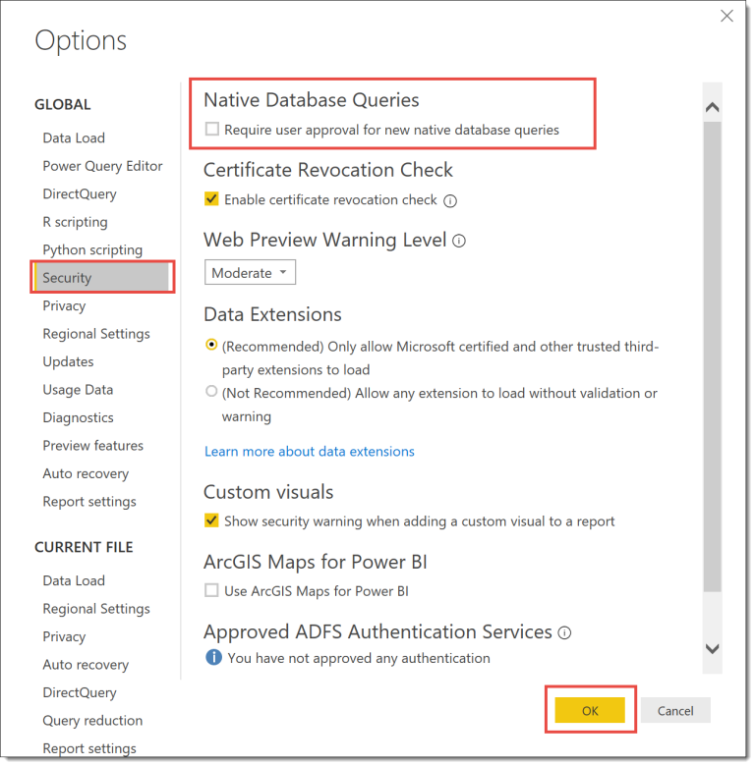

Figure 9 Disable Native Database Query Notification

# Environmental Setup

|  |  |  |  |
| --- | --- | --- | --- |
| Service Account | SA-APACFARework | | |
| Power platform Environment | M_APAC_Hyperautomation_[*DEV/UAT/PROD]* | | |
| On Premises Data Gateway | SA-APACFARework_DW | | |
| AX Server Name (SQL Server + Database) | **DEV** | **TST** | **PRD** |
| HKDATAPAXU02 | HKDATAPAXU02 | HKDATAXSQLP6 |
| ERPLITE_UAT | ERPLITE_UAT | ERPLITE_LIVE |
| Custom Security Role | **FA Rework Invoices – Basic User**  Dataverse Permissions:   * Access Permission: READ * Scope: Organization * Tables: The beforementioned 5 Custom Tables | | |

# Environmental Variables

To facilitate healthy ALM practices Environmental Variables are used throughout the Solution.

|  |  |  |
| --- | --- | --- |
| Environment Variable | Description | Value |
| AX File Share Path | Shared Folder Path for ORLI file -Source | |
| **DEV (Default Value):**  \\hkdatapaxu02\AX_Interface\UAT\CHK\APOLLO\IN\IN  **UAT (Current Value):**  \\hkdatapaxu02\AX_Interface\UAT\CHK\APOLLO\IN\IN  **PROD (Current Value):**  \\hkdataxfs001\AX_Interface\LIVE\CHK\APOLLO\IN\Archive | |
| Excel Invoice Template File ID | File ID of the Excel Template  (File Name: **FA Rework Inbound Vendor Excel Template.xlsx**) | |
| **DEV (Default Value):**  %252fInvoiceLib_DEV%252fTemplates%252fFA%2bRework%2bInbound%2bVendor%2bExcel%2bTemplate.xlsx  **UAT (Current Value):**  %252fInvoiceLib_TST%252fTemplates%252fFA%2bRework%2bInbound%2bVendor%2bExcel%2bTemplate.xlsx  **PROD (Current Value):**  %252fInvoiceLib_PRD%252fTemplates%252fFA%2bRework%2bInbound%2bVendor%2bExcel%2bTemplate.xlsx | |
| Excel Script ID | File ID of the Excel Script File  (File Name: **Fill-out FA Rework Invoice_[DEV/TST/PRD]**) | |
| **DEV (Default Value):**  ms-officescript%3A%2F%2Fonedrive_business_itemlink%2F01TLGYIMYVXGLM7LNTNJGIT6VQ73XNJ5M6  **UAT (Current Value):**  ms-officescript%3A%2F%2Fonedrive_business_itemlink%2F01TLGYIM3SKL7POBQBOZBJHJIZALHUFPBF  **PROD (Current Value):**  ms-officescript%3A%2F%2Fonedrive_business_itemlink%2F01TLGYIMZMCNW5OZ5EXFBZHUIA74UGMXLJ | |
| SP Library | SharePoint Invoice Library | |
| **DEV (Default Value):**  InvoiceLib_DEV  **UAT (Current Value):**  InvoiceLib_TST  **PROD (Current Value):**  InvoiceLib_PRD | |
| SP Library Drive ID | SharePoint Invoice Library ID | |
| **DEV (Default Value):**  b!1as_VFbviUOysUCZNTF6BDF-CHqMPRJJg79wwOLswfKX4QD0nMm6QoOQAElSmCf6  **UAT (Current Value):**  b!1as_VFbviUOysUCZNTF6BDF-CHqMPRJJg79wwOLswfLCuvL5JlozTZssLuYYnM7O  **PROD (Current Value):**  b!1as_VFbviUOysUCZNTF6BDF-CHqMPRJJg79wwOLswfL81dZN9kqBTo0AfLttTqDS | |
| SP Root Folder Path | SharePoint Root Folder Path of the Invoice Library | |
| **DEV (Default Value):**  /InvoiceLib_DEV  **UAT (Current Value):**  /InvoiceLib_TST  **PROD (Current Value):**  /InvoiceLib_PRD | |
| SP Site | Invoice SharePoint Site | |
| **DEV (Default Value):**  https://lpl.sharepoint.com.mcas.ms/sites/FARework  **UAT (Current Value):** N/A  **PROD (Current Value):** N/A | |
| Word Invoice Template File ID | File ID of the Excel Template  (File Name: **FA Rework Inbound Vendor Word Template.docx**) | |
| **DEV (Default Value):**  01DR2WT5BFPWWYMEWYDNEI2LYDVGKYMSJY  **UAT (Current Value):**  01DR2WT5ESNYCMM5KFSJAINHO43TCKJEMH  **PROD (Current Value):**  01DR2WT5GOQ4Z5PW3OMJAKIDKQ3A367EES | |

## License Requirements

### Service account

The Service Account will need to have a premium license for both Power Apps and Power Automate. This premium license will allow the developer to build the necessary Solution components without any limitations.

### Business Users

Business Users will need a Power Apps Premium license to be able to access the Dataverse tables. Any flows that will be executed run in the context of the Power App and are therefore covered by the Power Apps Premium license.

# Risk (R) and Dependencies (D)

D: Hyperautomation team’s access to:

* ORLI file server
* AX SQL server via Power Platform On-Premises Data Gateway

D: AX team to support with code (store procedure) to extract:

* Inventory variants
* Vendor name
* Vendor code

1. Power Platform Ecosystem consists of (1) Native Power Platform capabilities, (2) Microsoft 365, (3) Microsoft Azure, (4) Microsoft Dynamics 365, (5) Third Party Applications, (6) Pro Code Components